**Lab**

**Team No:** 04

**Members of the team:**

K. Harish

U. Amrutha Varshini

B.N. Mallikarjuna

T. Venkata Sai Kumar

Radha Chaurasiya

Vishal Babu

Ajay Prakash

**Research Title:**

A System On Chip (SOC) ASIC chipset for Aerospace and Energy Exploration Applications

**The solution aiming in this article:**

The article aims to provide a solution for developing a System On Chip (SOC) ASIC chipset that can be used in aerospace and energy exploration applications. This SOC chipset is designed to be reconfigurable, scalable, and capable of interfacing with various sensors and actuators in distributed control system architectures. The goal is to create a versatile and affordable building block that can address the challenges of high-temperature operation, miniaturization, flexibility, scalability, and performance capability in different applications.

**The architecture/block diagram given in the article:**

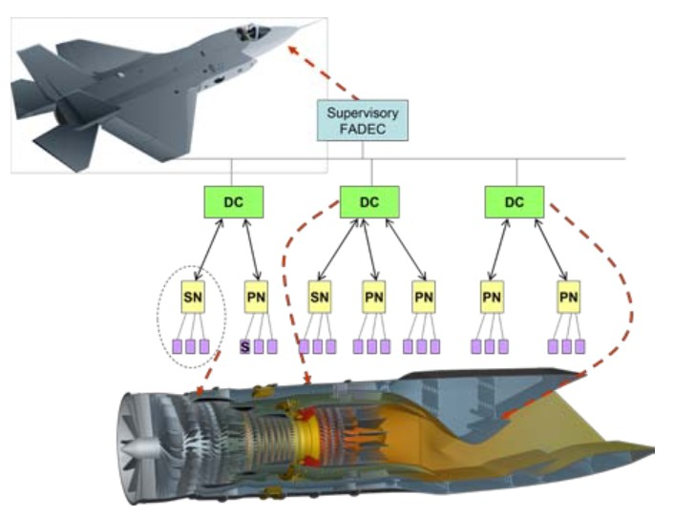

Distributed FADEC Architecture

**Functional description of the solution provided:**

1. Signal Conditioning Interfaces: The SOC contains 2 independent signal conditioning interfaces for Low Voltage sensors like RTD, TC, and SG. Each interface has a programmable excitation source, differential inputs, and a programmable bias offset for accurate sensor readings.

2. PWM Drives: The SOC includes PWM circuitry for driving up to 4 external Half Bridges. Each PWM output can be controlled independently to adjust speed, torque, and other motor characteristics through the local processor.

3. Analog Multiplexer: With 16 channels, the SOC's analog multiplexer allocates 9 channels for internal signals, leaving 7 channels available for external inputs, enhancing flexibility in signal processing.

4. Analog and Digital IO: The SOC chipset features uncommitted Op. Amps, comparators, and interfaces for 8 digital inputs and outputs, providing versatile options for interfacing with various devices.

5. RS485 Bus Interface: The SOC is equipped with bus transceivers to convert UART signals into fully compliant RS485 bus signals without requiring additional components, simplifying communication setup.

**Features of the IC:**

Key Features of the SOC Based Smart Node

* The SOC chipset is a reconfigurable and scalable building block designed for aerospace and energy exploration applications.
* It interfaces with various sensors and actuators, providing necessary functions for power, signal processing, and PWM circuitry.
* The chipset can be powered from different sources and offers flexibility in configuring functions for different applications.